# Training for the Holidays

Tom King

We took a train to Tahoe for Christmas. What a glorious trip through the snowy mountains!

**From Our Train Car Window**

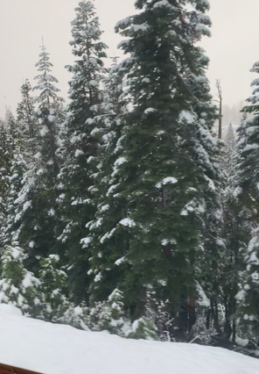

The train was smoother and quieter than I had imagined, and all the Amtrak people were friendly and helpful in spite of this being one of their busiest days of the year. Once the train got past Sacramento into Colfax, the scenery changed from Central Valley yuck to snowy Sierra wonder.

OK, the train actually left from the Emeryville Amtrak Station, and then we got off in Truckee. Our daughter-in-law, Jennifer, met us and chauffeured us from Truckee to their ski place in nearby Martis Camp, where we joined 11 people for the holidays. Here’s a picture of some of the kids and the presents patiently awaiting them under the tree:

**Christmas Kids at Tahoe**

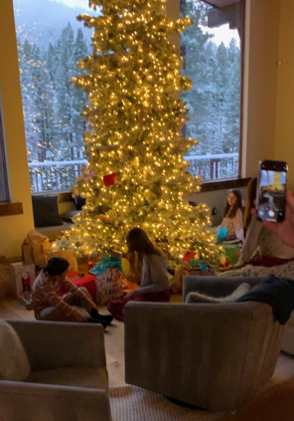

Coming back had me driving a rented Jeep Wagoneer with 5 passengers through a snowstorm with chain controls on a busy and slippery I-80. Where’s the train when you need it?